Boy Scout Troop 76
Annual Holiday Wreath Sale
www.bsatroop76ctwreathsales.com
or hold your phone’s camera to this QR Code
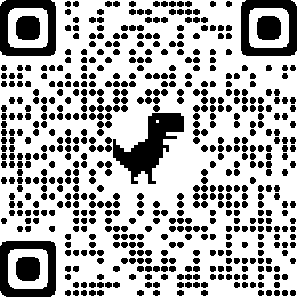

Beautiful, Fresh Pine Wreaths, pre-decorated with a red bow and pinecones.
Item | Cost per item | Quantity
18 inch wreath | $22.00
24 inch wreath | $27.00
30 inch wreath | $40.00
25 feet pine roping | $25.00
50 feet pine roping | $45.00
75 feet pine roping | $65.00

All proceeds help Troop with expenses associated with camping, general expenses, and local service projects. Thank you for your support.
Customer Name: ___________________________
Customer Address and Phone: _____________________________________________
Scouts Name for delivery: _________________________________

